Competition Information
Event: Scottish Athletics West District Cross Country Championships
Date: Saturday 7th December 2013
Venue: Ayrshire Athletics Arena (AAA), Queens Drive, Kilmarnock, KA1 3XF
Medals
There will be individual medals for 1st, 2nd and 3rd in each race except Masters Over 50 (1st only).
There will also be 1st, 2nd and 3rd team medals – normally 3 to count, except Senior Men (6) and Senior Women (4). There will only be team medals for the 1st Masters Team.

Important Notes
The Senior, Masters and Masters O50 races are combined for each gender.
All athletes may count in the Senior championships race as well as their own age category.
Masters can also count in both the Senior and Masters team races.
In scoring the Masters team placings, only Masters athletes are considered.

Directions
Travelling south on the M77/A77 take the 3rd exit for Kilmarnock. The AAA is close to the major intersection between the A77, A76, A71 and A735. Follow the signs for the A735 / Town Centre to reach the AAA.

Parking
Parking at the AAA is for local users and West District officials only.
Follow map and directions on the following page for Competitor Parking.

Registration / Declarations
Declarations are in the indoor track area from 10.00am. Please remove muddy shoes before entering. Course maps and race details will be available at Registration.

Changing
There are 6 male and 3 female changing rooms, each equipped with multiple showers (except disabled changing rooms which are to be used but have only 1 shower). There is additional male changing in the curtained area at the end of the indoor track.

Toilets
There are toilet facilities in the changing rooms and in the main toilets within the AAA which is within 100m of the Start.

Warming-up / Course Access
Please keep clear of the football pitches. To gain access to the Start / Finish and Team Tent area you are required to cross the course. Please stay within markers and watch out for runners.

First Aid
First Aid will be located near the Start/Finish area.

Club Tents
There is ample space for club tents near the Start/Finish area. Please assemble tents in the marked bays around the Cricket Circle.

Catering
Soup and crusty bread plus tea and coffee will be on sale in the AAA and there will be a catering van providing a wider range of hot and cold food outside the building.

Queries
On the day, please address queries about the race to the Referee or Chief Timekeeper.

Many thanks to all the officials for their invaluable and much-appreciated help, and to Kilmarnock Harriers for generously hosting the event. Results will be posted on the Scottish Athletics website.

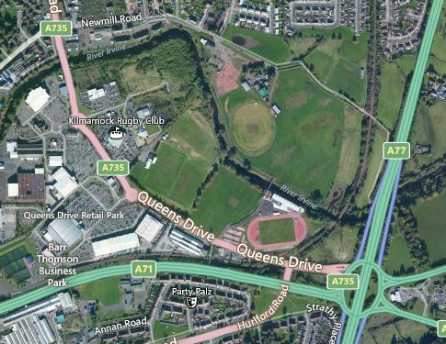

Ayrshire Athletics Arena
Competitor
Parking

Pedestrian Route to AAA
Start / Finish

Ayrshire Athletics Arena Parking

  - The AAA is close to the major intersection between the M(A)77, A71 and A76. Follow the signs for A735/Town Centre.

  - Parking at the AAA is for local users and West District officials only. Follow map and directions below for Competitor Parking

  - From the Ayrshire Athletics Arena, continue on Queen’s Drive/A735 for 0.1 miles (yellow dotted line) and at first roundabout take the second exit. Continue for 0.2 miles and at roundabout take the second exit.

  - Move into outside lane and turn right at the traffic lights onto Newmill Road.

  - Continue for 0.3 miles and competitor car park is on the right

